In the previous discussions as I mentioned about my research question, which is “What is the best candy during Halloween?” to figure that out I have chosen linear and logistic regression models. From linear regression model I have figured the variable which has highest confident when coefficients are calculated, as you can see below:

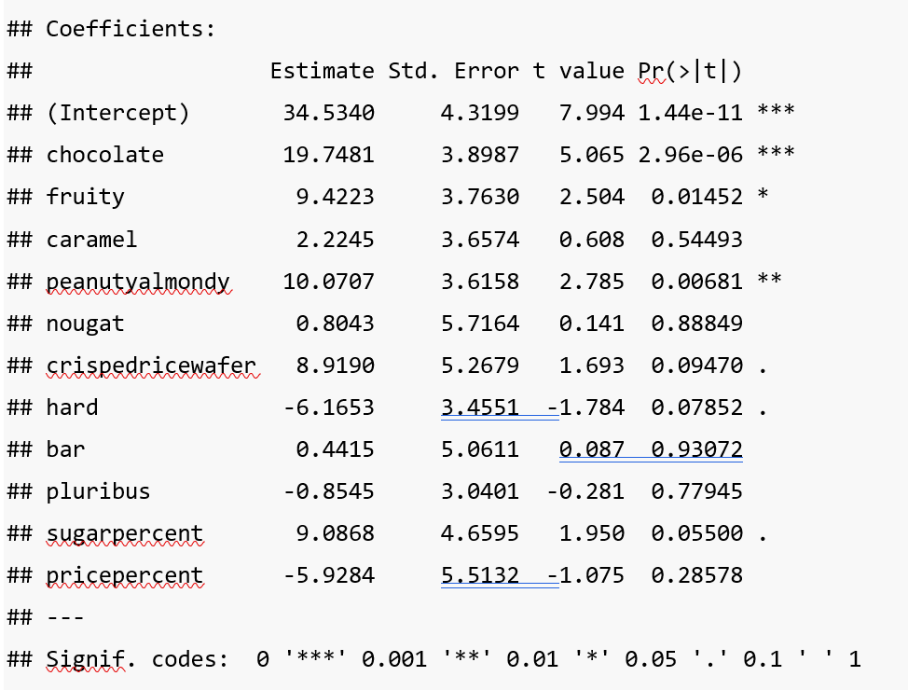

Here chocolate has three * which indicates the 99.9% confident which means if we consider this variable, we can predict the most accurate values.

By considering this variable I have create a logistic model to measure the accuracy that this chocolate variable we considered has more demand. To calculate accuracy, I have also built a table between actual values and predicted values which is called confusion matrix a shown below:

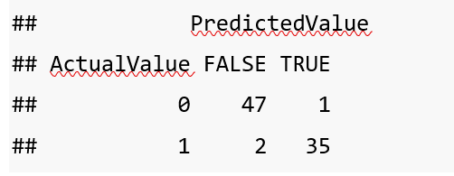

Let me explain those values in the matrix, this is the comparison between the actual table values of the chocolate column and predicted values of the chocolate. It has 47 true that the value of chocolate is 0 in both actual table and the predicted table, only 1 time it predicted value is false. In the next case, the prediction of chocolate value is 1, in which it is 35 time true and 2 times its false. Which is a pretty good prediction.

Now to calculate the accuracy of this model we need to find it’s sum of the correct instances which is diagonally represented in the above matrix and divided by the total number of instances i.e.,

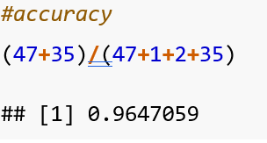

**Representing it in a plot:**

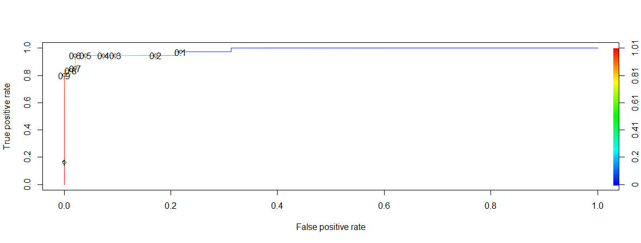

In x axis there is False positive rate, and in y axis True positive rate. As you can see all the values of the plot are indicated in good range of true positive rate which means the values are predicted nearer to accurate, where as the range of values of false positive rate is less which is also means the prediction is neared to accuracy.

So, my next future tasks are to will carry these predictions on other variables and see if there are any other variables which has better performance than chocolates. And compare those result and find the candy which has most demand during Halloween.

**Reference:**

1. <https://www.youtube.com/watch?v=Z5WKQr4H4Xk>